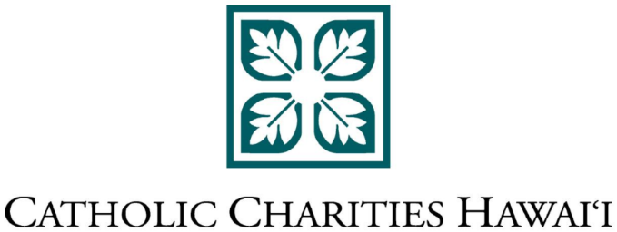

FOR IMMEDIATE RELEASE

MEDIA CONTACTS:

Caroline Witherspoon

or Scott Ishikawa

Becker Communications, Inc.

(808) 533-4165

**CATHOLIC CHARITIES HAWAI‘I SEEKING DONATIONS**

**TO PROVIDE TEMPORARY HOUSING  
FOR NATURAL DISASTER VICTIMS on HAWAI‘I ISLAND AND KAUA‘I**

(May 10, 2018) – In the wake of the Kaua‘i floods and volcanic activity on Hawai‘i Island, Catholic Charities Hawai‘i (CCH) is asking the public for monetary donations that will go directly to temporary housing or necessary repairs for those affected on both islands.

Donations and related funding will help Kaua‘i flood victims with temporary supplemental housing subsidies and support while their current homes are being repaired, and Puna residents who evacuated their homes due to the ongoing volcanic activity, said CCH President and CEO Terry Walsh.

Catholic Charities Hawai‘i has applied for $10,000 emergency seed grants through the national organization, Catholic Charities USA, for both areas being affected by the recent natural disasters. Public donations and other qualifying CCH funding supplementing the emergency grant money will go directly for rent subsidies, emergency home repairs and other related needs to those who apply and qualify, Walsh said.

“We understand that certain agencies and first responders are there on both islands to ensure the health and safety of those being affected,” Walsh said. “CCH’s role is to assist those affected through recovery efforts during these disasters.” CCH helped with long-term recovery efforts during the last lava flow through Puna in 2014 and following the 2006 Hawaii Island earthquake. CCH’s Kauai office was founded in 1992 in response to the recovery needs after Hurricane Iniki.  
  
Because of CCH’s statewide network and partnerships with other social service agencies, the organization will work with their partners to reach out to the communities affected, Walsh said. Those affected by the two disasters and wishing to apply for emergency subsidies through CCH can contact our Hilo office at (808) 935-4673 or our Kaua‘i office at (808) 241-4673.

Walsh said CCH donors can specifically make donations to those affected on Kaua‘i and Puna. “Any specified donations will go directly to those needing help in these two areas,” Walsh said.

**There are numerous ways to give to Catholic Charities Hawai‘i including:**

Online – [www.catholiccharitieshawaii.org/relief-support/](http://www.catholiccharitieshawaii.org/relief-support/)

By Phone - Call (808) 527-4820

By Mail - Print out a donation form online, fill out, and mail with your gift to Catholic Charities Hawai‘i, 1822 Ke‘eaumoku Street, Honolulu, HI 96822

For more information, please visit [www.CatholicCharitiesHawaii.org](http://www.CatholicCharitiesHawaii.org).

**About Catholic Charities Hawai‘i**

Serving Hawai'i since 1947, Catholic Charities Hawai’i offers assistance to people in need, regardless of faith or culture. Long trusted in the community for their innovative and professional approach to human services, Catholic Charities Hawai'i touches the lives of tens of thousands of people each year through programs statewide. The agency is fully accredited through the Council on Accreditation. Catholic Charities Hawai‘i is a partner agency of Aloha United Way and a member of the nationwide Catholic Charities USA network. For more information visit [www.catholiccharitieshawaii.org](http://www.catholiccharitieshawaii.org).

# # #

--

Scott Ishikawa, Senior Account Executive  
119 Merchant St, Ste 300 | Honolulu, HI  96813  
T: (808) 533-4165 | C: (808) 227-2350

[www.BeckerCommunications.com](http://www.beckercommunications.com/)

